Project Design Documentation Template:
Last updated: June 13th, 2025

- Project Title & Version Control

Cloud-Native SOC: Real-Time Detection & Automated Remediation with Microsoft Sentinel
Version Control: 1.0 (Initial Design)
Version: DRAFT
Date: 03/10/2026
Change Log: N/A Initial Documentation Base

2. Project Summary (2–3 sentences)
To build a functional, automated Security Operations Center (SOC) within a cloud environment. This project demonstrates the ability to identify "low-signal" brute-force attacks and utilize automation (SOAR) to neutralize threats in real-time.

Problem Statement / Use Case
What real-world problem does this solve? Who would use this? What user, business, or system need is this project being designed to address?
.1 The Problem: Modern organizations face constant, automated brute-force attacks that overwhelm manual security teams. Without automation, attackers can attempt thousands of credentials before an analyst can react, leading to high breach risks and "alert fatigue."
3.2 The Need: This project addresses the business need for 24/7 automated defense. It provides a system that identifies and neutralizes high-volume threats instantly, allowing small security teams to focus on complex investigations rather than repetitive manual blocking.

4. Goals and Objectives
- Goal 1: Centralized Visibility. Establish a continuous log pipeline from the Windows "Honeypot" to Microsoft Sentinel, ensuring 100% of failed authentication events are ingested for analysis.
- Goal 2: Automated Containment. Develop a SOAR playbook that extracts malicious IP addresses from alerts and automatically updates firewall rules to block the source in under 60 seconds.
- Goal 3: Threat Intelligence Visualization. Create a functional Security Workbook (Dashboard) that maps the geographic origin and frequency of attacks to provide actionable insights into global threat trends.

5. Key Features / Functions
What are the main things your project will do? List the main features you expect the final project to include.
- Real-Time Log Streaming: Continuous ingestion of Windows security telemetry into Microsoft Sentinel for live monitoring.
- KQL Detection Logic: Custom-built queries to isolate and alert on high-velocity brute-force patterns.
- Autonomous SOAR Response: An automated playbook that extracts malicious IPs and updates firewall rules to block attackers in real-time.
- Interactive Threat Map: A visual dashboard mapping the geographic origin and frequency of global attack traffic.
- Automatic Incident Generation: Self-creating security tickets that include all relevant evidence and attacker metadata for investigation.

6. Technical Requirements
- Platform: Azure Free Tier (Subscription).
- Services: Microsoft Sentinel (SIEM) & Log Analytics Workspace.
- Endpoint: 1x Windows Virtual Machine (Size: Standard B1s).
- Networking: Azure Network Security Groups (NSG) for firewall control.
- Automation: Azure Logic Apps (SOAR) for IP blocking.
- Languages: KQL (for querying) & JSON (for automation logic).

6. Tech Stack and Tools
Languages, frameworks, platforms, or security tools you'll use (e.g., Python, Flask, PostgreSQL, Zeek, Wireshark). List the tools and technologies you expect will be needed to build this project in later semesters.
- Cloud Platform: Microsoft Azure (Infrastructure & Networking).
- SIEM/SOAR: Microsoft Sentinel (Detection & Automation).
- Data Lake: Azure Log Analytics Workspace (Storage).
- OS/Endpoint: Windows 10/11 (Honeypot/Target).
- Languages: KQL (Kusto Query Language) & PowerShell.
- Automation: Azure Logic Apps (JSON-based workflows).

7. Architecture / Workflow Diagram
Algorithm and Flowchart for project. Show how the project moves from user action or input to system response or output. Show the planned flow of the system, including how a user, action, or input moves through the project from start to outcome.

7.1 The Algorithm
This is the logic that governs how the system detects and responds to threats:
- Event Ingestion: The Windows VM generates a log (Event ID 4625) for every failed login attempt.
- Telemetry Sync: The Azure Monitor Agent (AMA) streams these logs to the Log Analytics Workspace.
- Threat Detection: A KQL query runs in Microsoft Sentinel every 5 minutes to count failed attempts per IP address.
- Incident Trigger: If the count exceeds 10 attempts, Sentinel creates a high-priority Security Incident.
- SOAR Execution: The incident triggers an Azure Logic App (Playbook).
- Automated Block: The Logic App extracts the malicious IP and adds a Deny Rule to the Network Security Group (NSG).
- Closure: The system updates the dashboard and closes the incident as "Auto-Remediated."

7.2 Workflow Flowchart
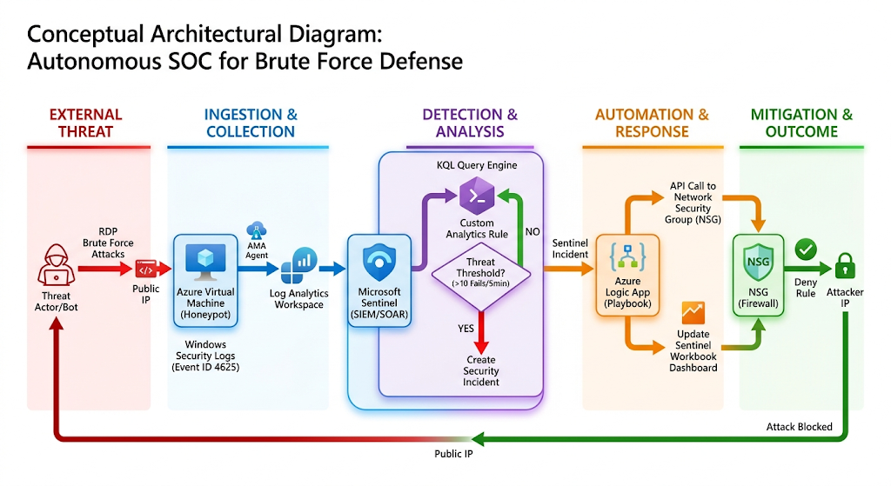

8. Timeline / Weekly Milestones
Use this section to show how your project will move through a simple software development life cycle during this four-week sprint.
 |  | Week | Phase | Outcome
 |  | Week 1 | Project Definition | Identified the Cloud-Native SOC concept. Defined the purpose: automating brute-force defense to solve the problem of manual monitoring latency.
 |  | Week 2 | Requirements and Goals | Defined the target users (SOC Analysts/SMBs). Established technical goals: 100% log visibility, < 60s response time, and global threat visualization.
 |  | Week 3 | Solution Planning and Design | Outlined the Sentinel + Logic Apps architecture. Designed the workflow from VM log ingestion to KQL detection and automated NSG blocking.
 |  | Week 4 | Review and Refinement | Identified risks like "False Positives." Defined success metrics (MTTR). Outlined future steps like adding multi-factor authentication (MFA) alerts.

9. Risks and Risk Mitigation
What risks are there to successful completion of the project and what can you implement to mitigate the impact of those risks. Consider risks such as unclear scope, missing requirements, unrealistic goals, or tool limitations.

Risk | Mitigation Strategy
Scope Creep | Focus strictly on RDP Brute-Force; exclude web or database attacks for the initial sprint.
Unrealistic Goals | Prioritize manual log ingestion first, then move to automation only after detection works.
Budget Overruns | Use Azure Free Tier credits and set strict "Auto-Shutdown" schedules for the VM.
Tool Limitations | Use the Azure Monitor Agent (AMA) rather than legacy agents to ensure 2026 compatibility.
False Positives | Hard-code a whitelist of your own public IP address into the KQL query to prevent self-locking.

10. Evaluation Criteria
How will you know this is done well? List at least 3 measures of success. Think about how you will know the project plan is clear, realistic, and ready to guide development in later semesters.
- Detection Accuracy: The system must achieve a 0% False Negative rate for active brute-force attacks, meaning every event exceeding the defined KQL threshold (e.g., 10 failed attempts) successfully triggers an Incident in Sentinel.
- Operational Speed (MTTR): The automated response must demonstrate a Mean Time to Respond (MTTR) of under 60 seconds from the moment the alert is generated to the "Deny" rule appearing in the Azure Firewall (NSG).
- Plan Feasibility & Clarity: The project plan is considered "done well" if a third party can replicate the environment using the provided Architecture Diagram and KQL scripts without external guidance.
- Data Visualization: The Sentinel Workbook must successfully populate a live global map, proving that the system is correctly parsing and enrichment geographic data from raw IP logs.

11. Future Considerations
What long term maintenance or added functionality will be needed in the future. What would you improve, expand, or maintain in a later version of this project?

11.1 Key Improvements & Expansion
- Multi-Vector Detection: Expand KQL logic to detect Password Spraying, MFA Fatigue, and Privilege Escalation attempts.
- Threat Intelligence: Integrate AlienVault OTX or VirusTotal APIs to automatically verify if an IP is a known malicious actor before blocking.
- Multi-Cloud Scale: Extend the Sentinel architecture to monitor and protect AWS or Google Cloud environments from a single dashboard.

11.2 Long-Term Maintenance
- Rule Tuning: Quarterly reviews of KQL thresholds to reduce False Positives.
- API Management: Regular updates to Logic App connectors to ensure compatibility with evolving Azure security schemas.
- Cost Optimization: Implement data lifecycle policies to archive old logs to Azure Blob Storage, keeping the SIEM budget-friendly.

12. Final Project Summary
This project transforms a vulnerable honeypot into an autonomous SOC. By shifting from manual monitoring to Real-Time SOAR, it proves that cloud infrastructure can be defended at .

